INDEX
05-08-2024
- Languages & Packages
- Java Features
  - Why Java is platform independent
- JDK, JRE, JVM
- Basic Java
  - Datatypes
  - Operators
  - Conditions(if, if-else)
  - Loops(Nested for loops)
- Packages
CoreJAVA-Workspace :
CoreJAVA-Development
CoreJAVA-Application
06-08-2024
- Logical Programming
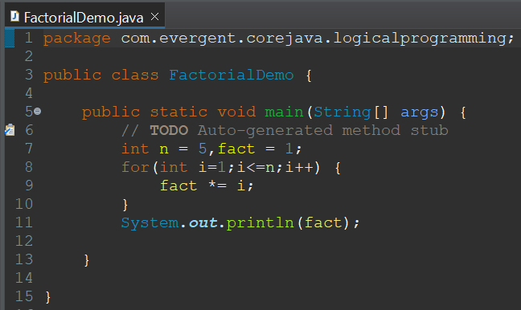
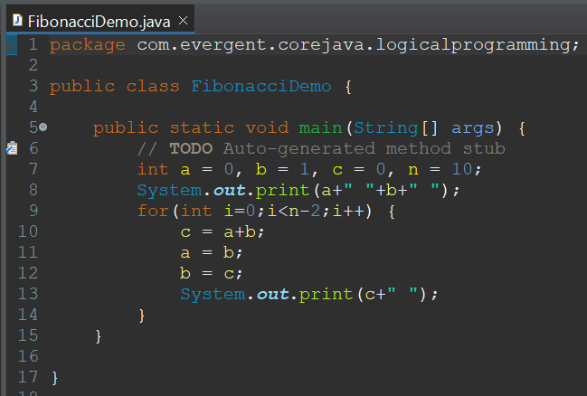
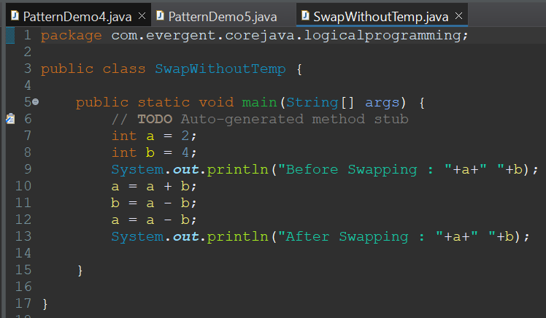
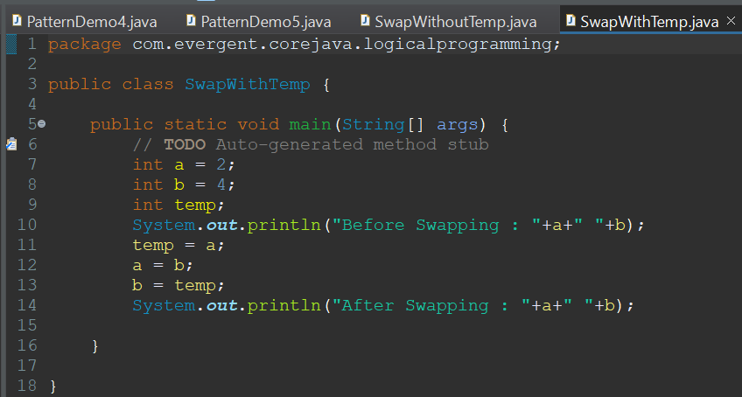
- Patterns
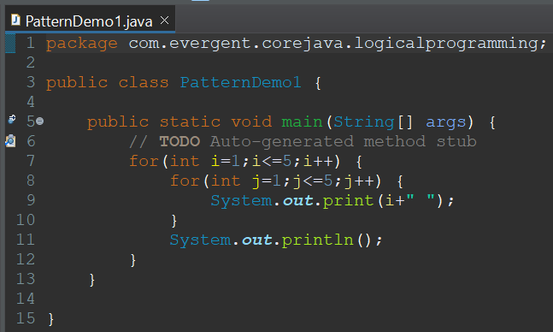
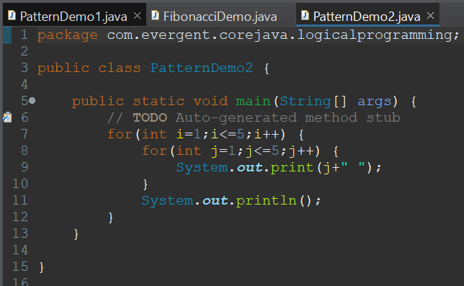
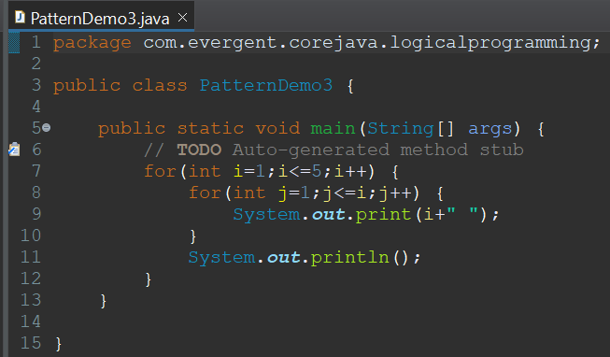
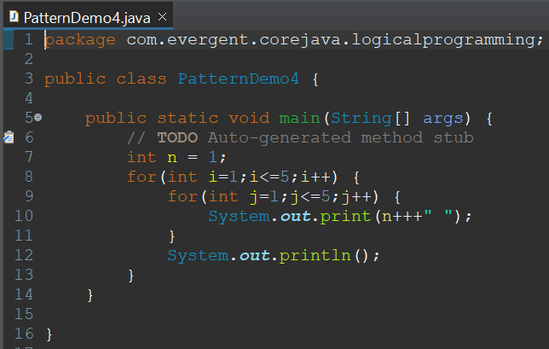
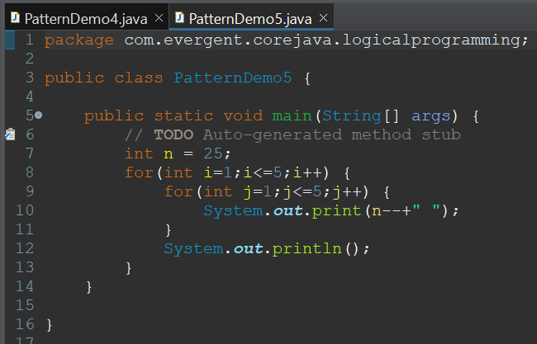
- Switch Case
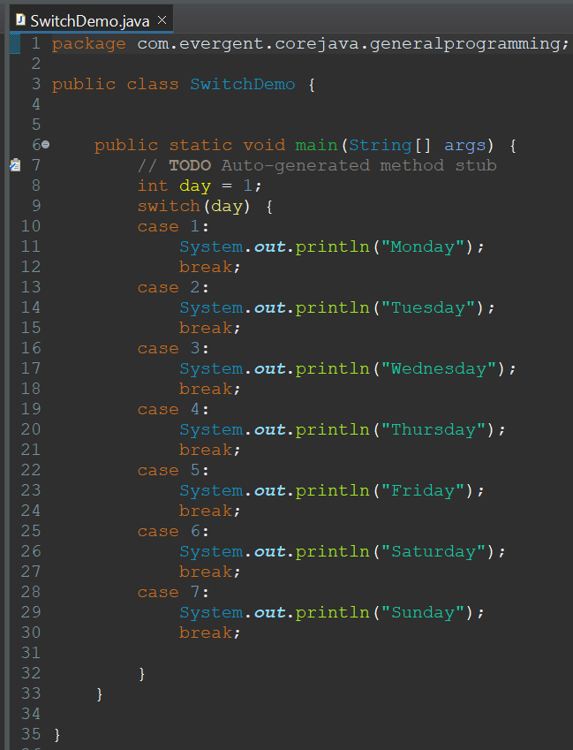
- Arrays
  - 1D Array's
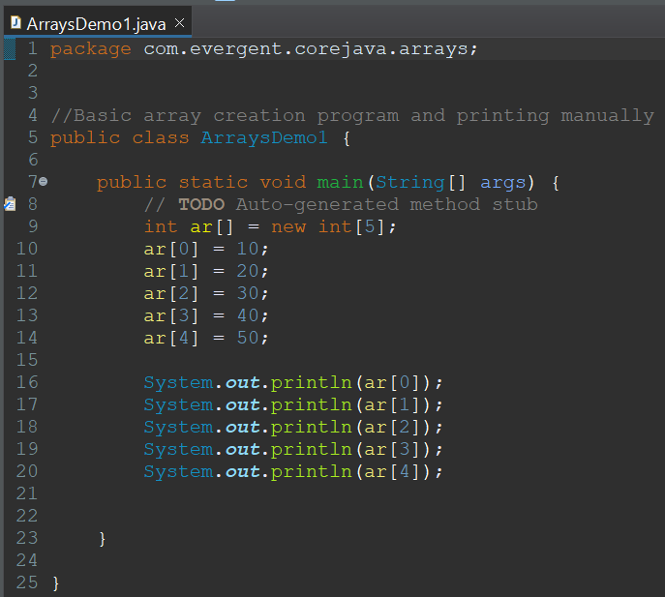
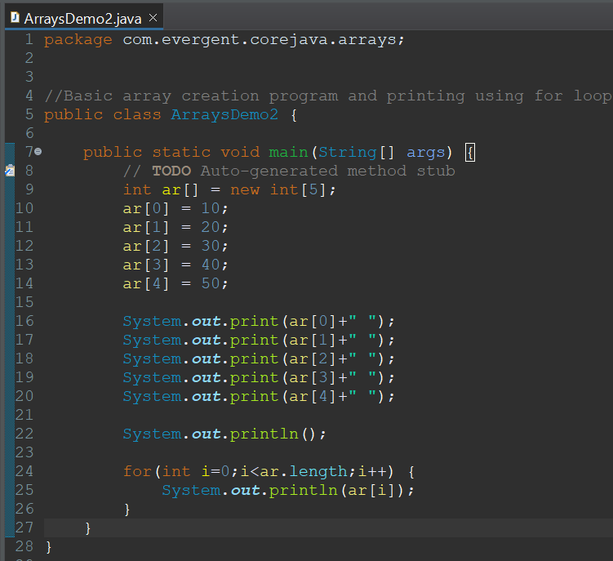
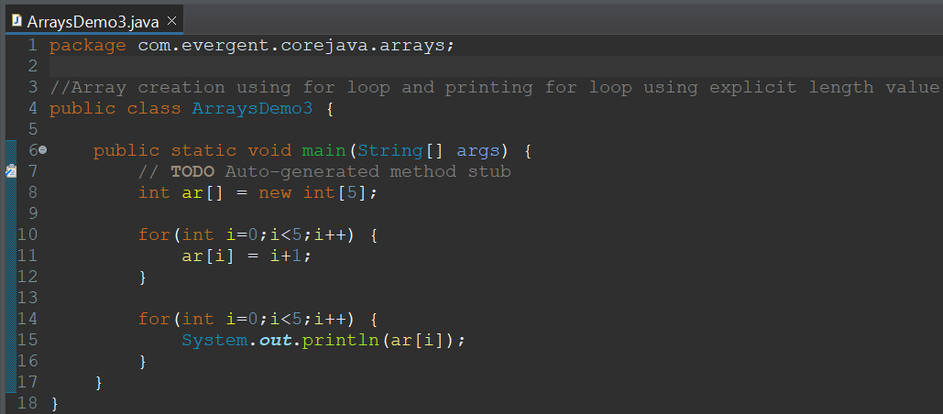
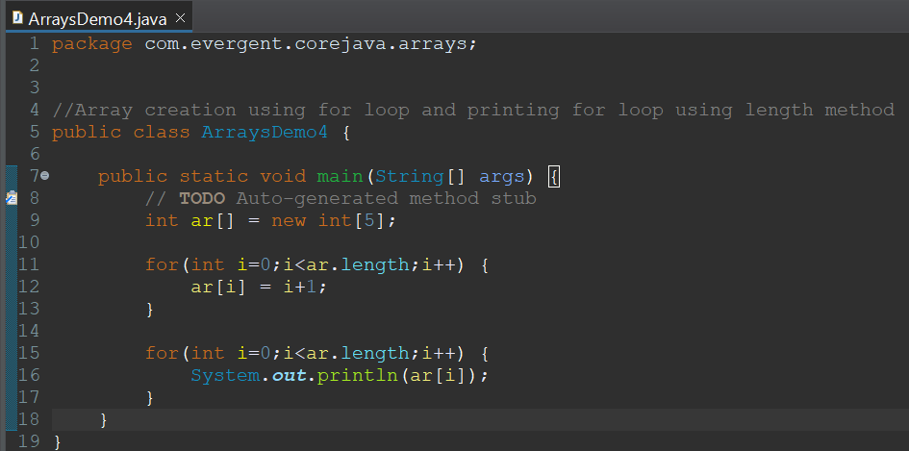
  - 2D Array's
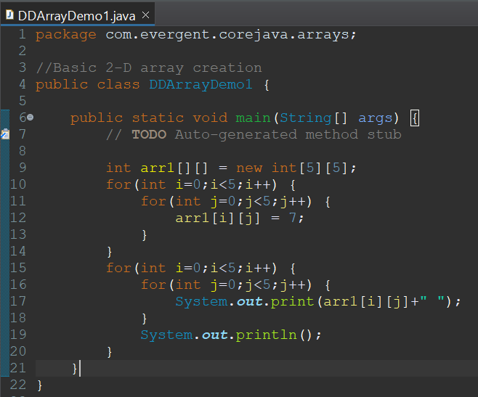
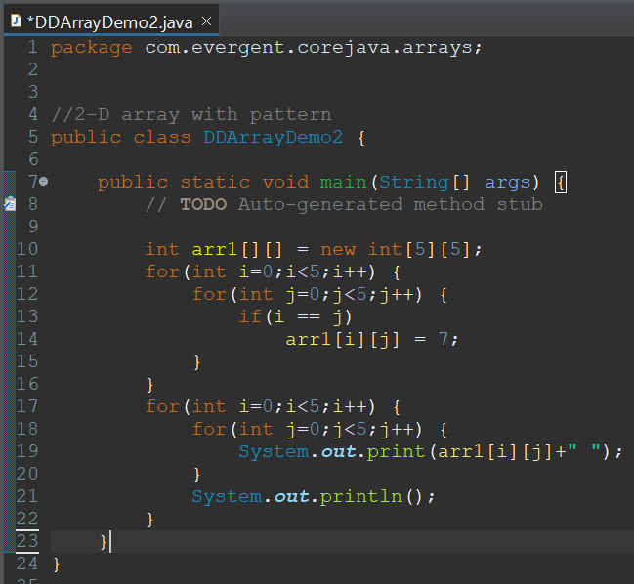
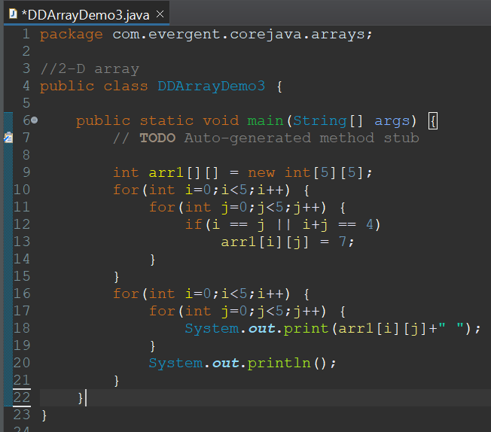
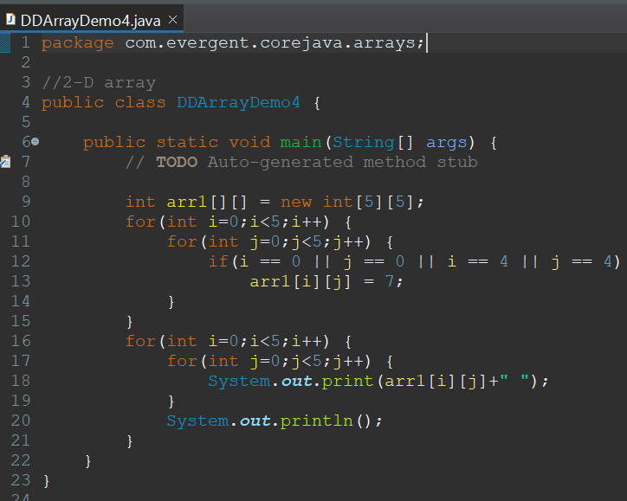
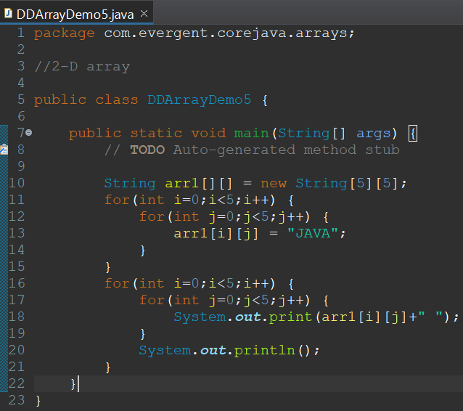

- Enum's
- Event Management System
07-08-2024
- OOPS
  - Encapsulation
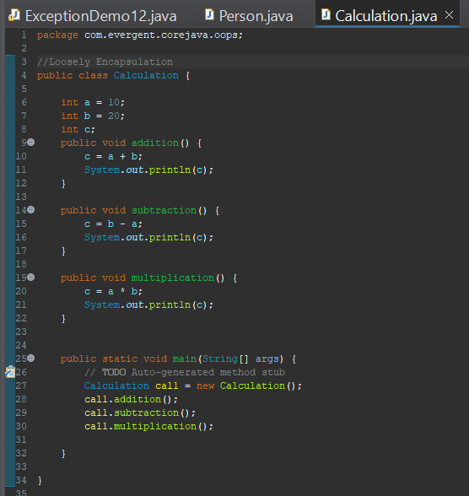
  - Inheritance
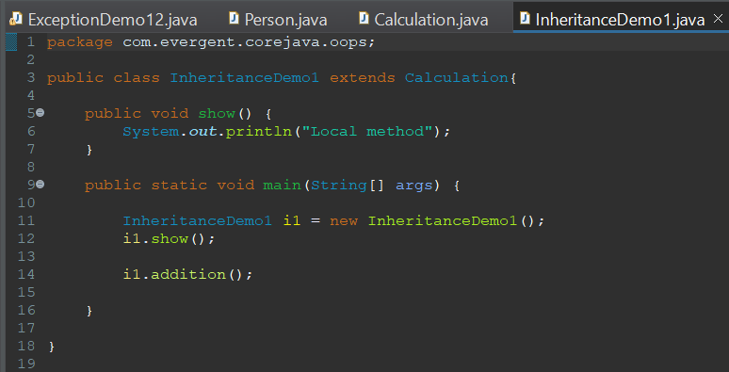
  - Polymorphism
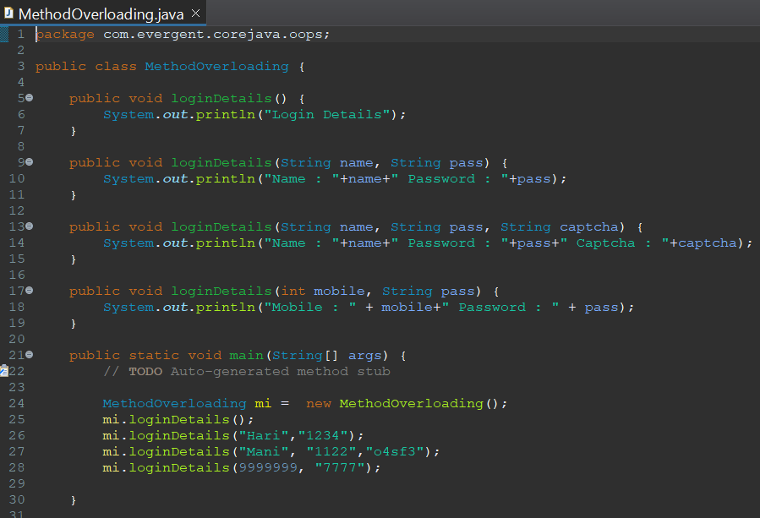
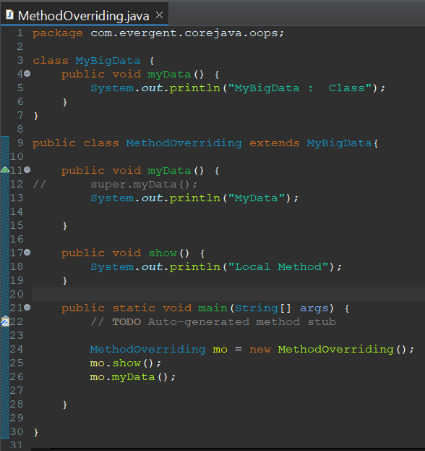
  - Abstraction
  - Method Flows
  - IS-A and HAS-A relationship
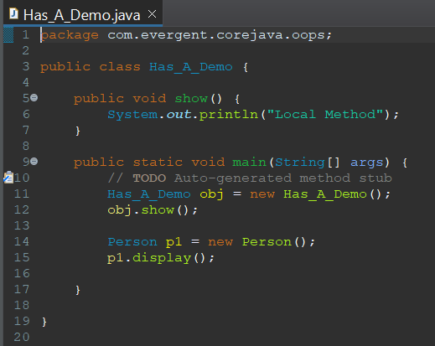
- System class
08-08-2024
- Constructors
  - Constructor name should be equal to class name
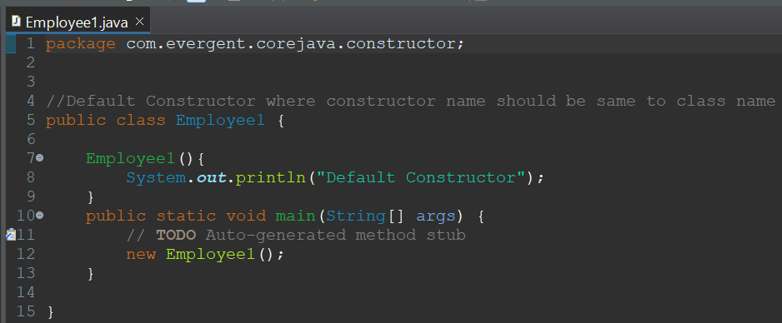
  - There are 2 types of constructor
    - Default
    - Parameterized
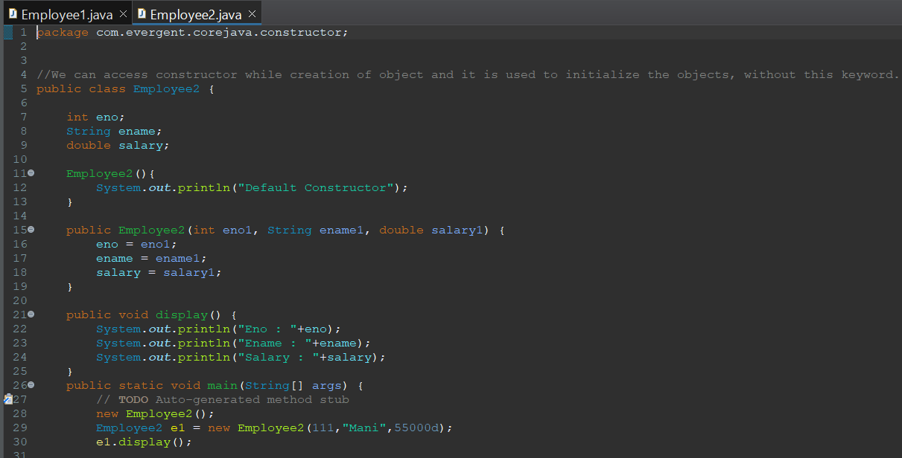
  - Constructors are called during object creation
  - Constructors are used for initialization of objects
  - Constructors doesn’t have return type not even void, if we define return type for constructors it will act as method
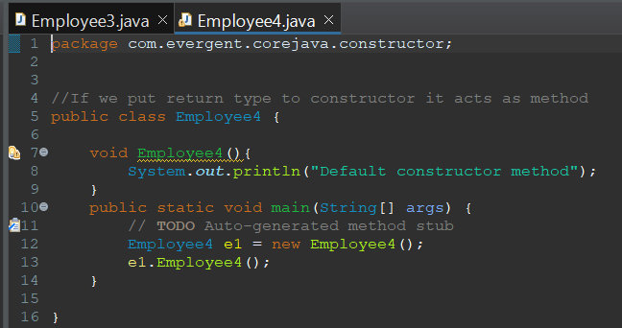
  - Every class will have default constructor
  - this & super are used
  - Also have other type of constructor called Copy Constructor
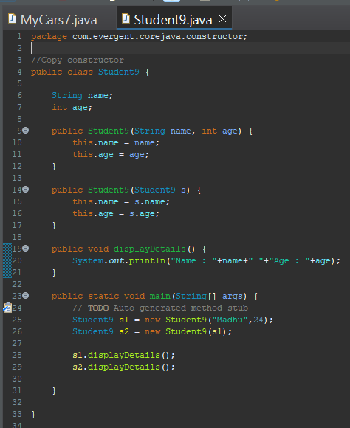
  - Constructors can be overloaded, but cannot be overridden
  - Constructor chaining - this() is used to call current class constructor, super() is used to call super class constructor
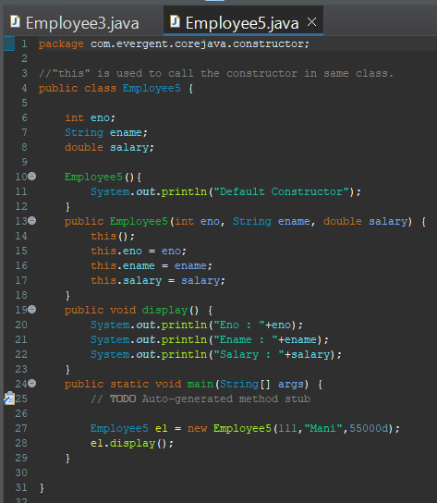
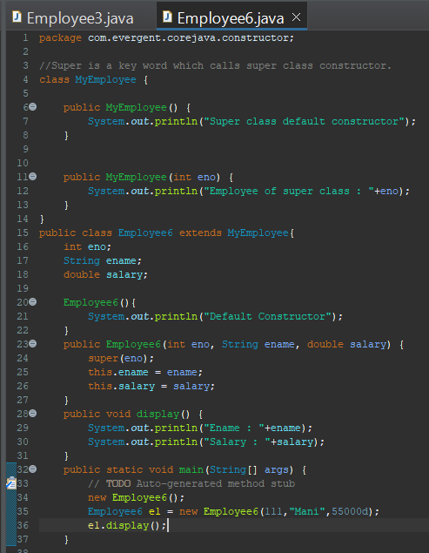
09-08-2024
- Static
  - Static is a keyword
  - We can declare variables and methods as static
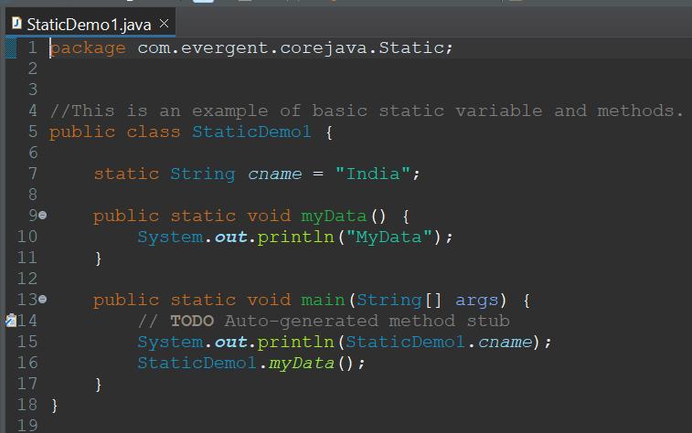
  - Static variables and methods are called by using ClassName.method and Classname.Variables
  - Static method can access Static variables and Static methods
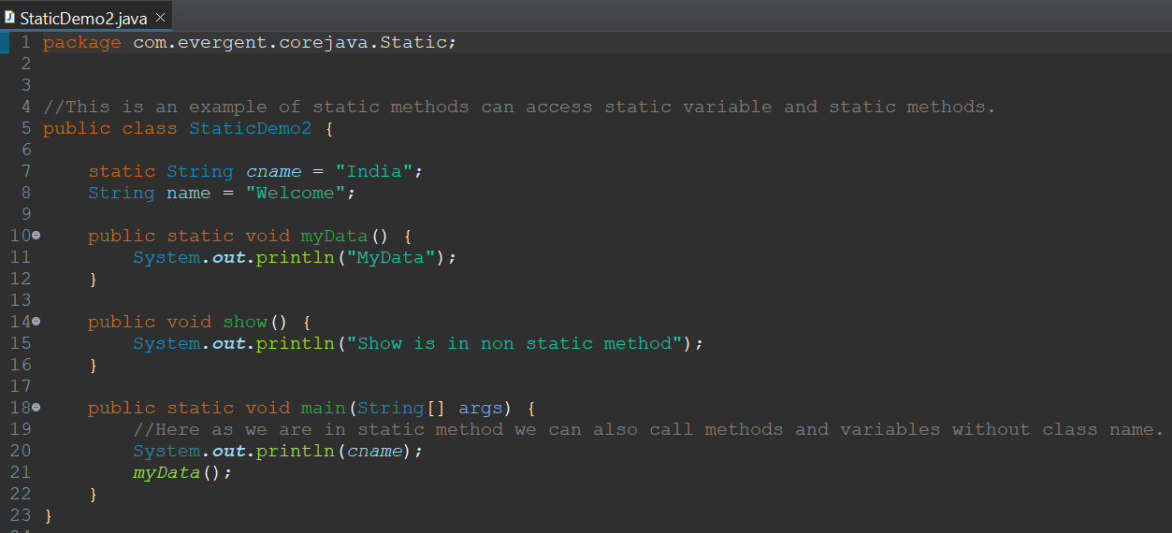
  - Static method cannot access Non static variables and Non static Methods
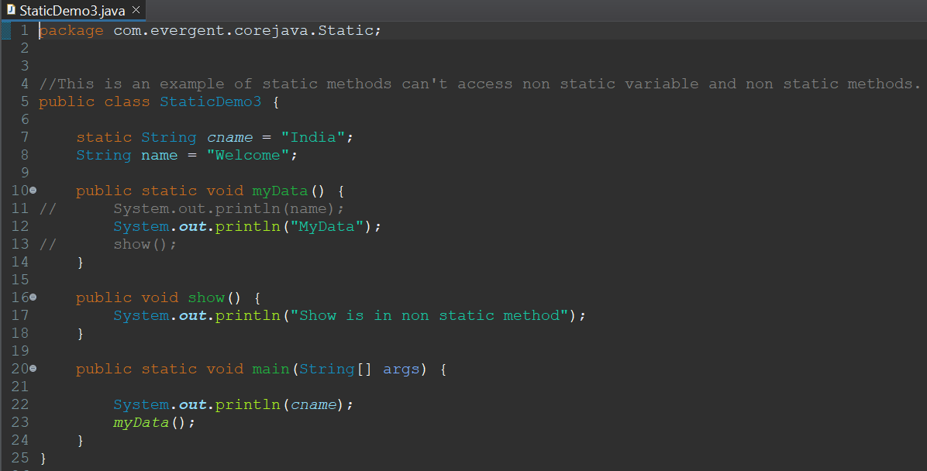
  - Non static method can access Static variables and Static methods
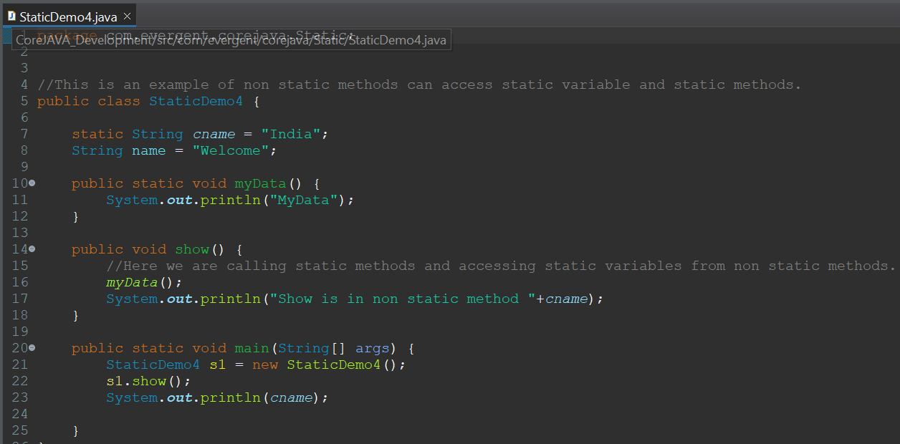
  - Static block is initialized first during class loading
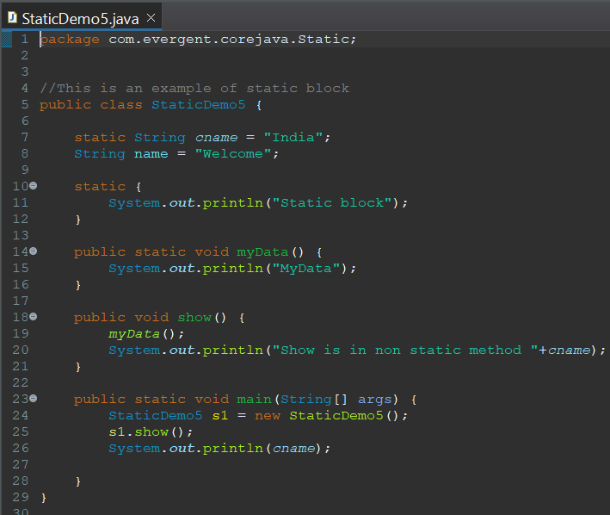

- Final
  - Final is a keyword
  - We can declare Variables, Methods, Classes as final
  - Final variables cannot be changed
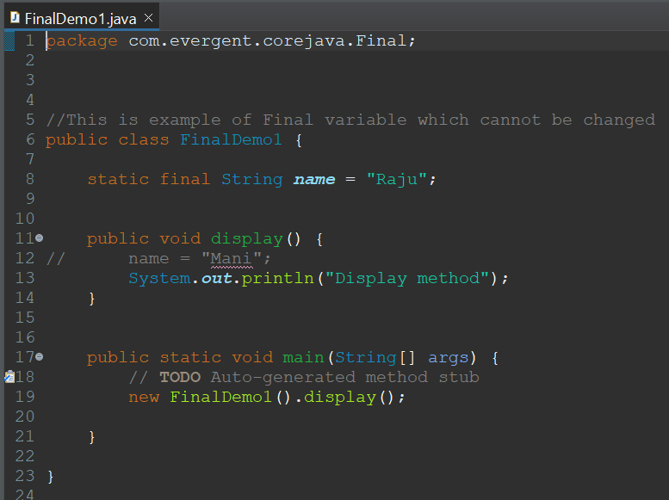
  - Final methods cannot be overridden
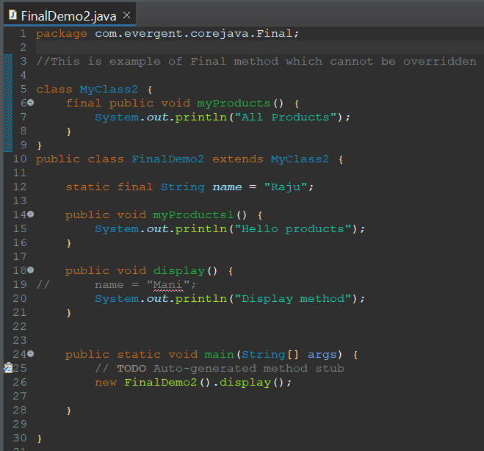
  - Final classes cannot be extended
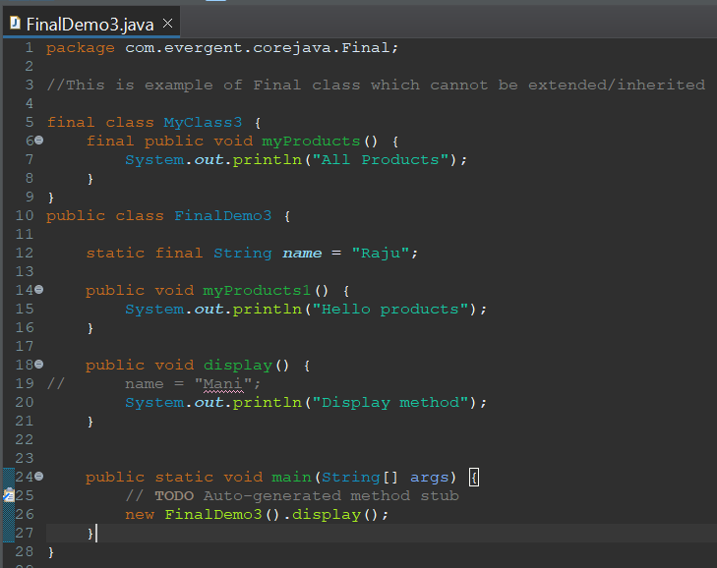
  - Final variables can be initialized through constructor or object creation
  - Final variable can be accessed through HAS-A relation ship

12-08-2024
- String
- String Class
- String Buffer
- String Builder
- String Class
- String class is final
- String is immutable
- All string class methods are non synchronized
- String Buffer
- String Buffer class is final
- String Buffer is mutable
- All string buffer class methods are synchronized
- String Builder
- String Builder class is final
- String Builder is mutable
- All string builder class methods are non synchronized
S.No | String | String Buffer | String Builder
1. | Final class | Final class | Final class
2. | Immutable | Mutable | Mutable
3. | Non Synchronized(Not Thread safe) | Synchronized(Thread safe) | Non Synchronized(Not Thread safe)
4. | String constant pool area | Heap area | Heap area

HEAP AREA

“JAVA”

STR1
“JAVA”
String Object
“JAVA”
STR2
STRING POOL AREA

S1

String Literal
S2

String class points
- In java a string is a sequence of characters, often used to represent text.
- String are objects in java & instance of string class which is part of java.lang.package.
- Key features of string in java
  - Immutable : Once a string object is created it cannot be changed.
  - Any modification to string creates a new string object
- Java optimizes memory usage by storing strings in a special way area of memory called “String Constant Pool”.
- If two strings have same value and are created without using new keyword they will refer to same object in string pool.
- We can create string using in two ways :
  - Using String literals
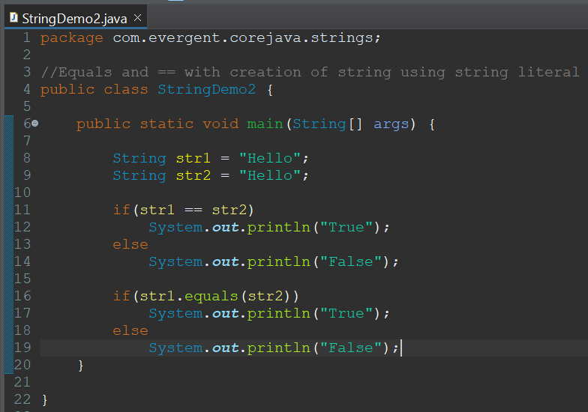
  - Using new keyword
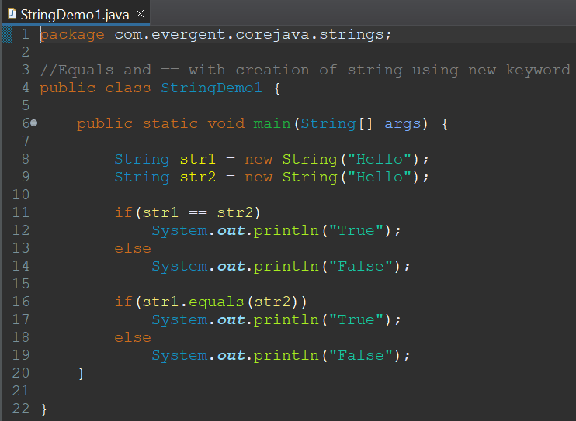

- In string
  - equals() is used to compare the content
  - == is used to compare the memory of the two objects
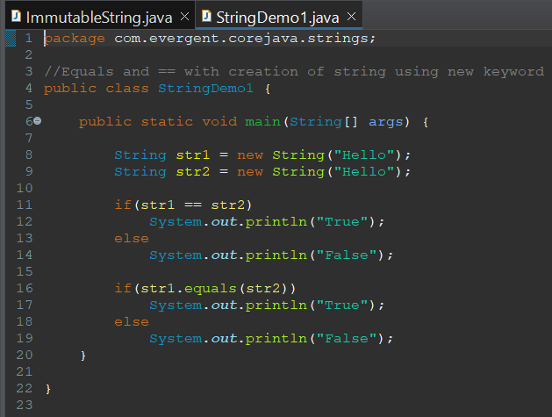

13/08/2024
- Interface
- Interface is keyword
- We can declare method signature only but not implementation
- By default all interface methods are abstract
- If any class implements interface then class should be override all interface methods otherwise the class will be showing compile time error
- We cannot create object to interface but we can create reference to it
- We can declare variables inside interface by default they are public static final
- Java will support multipple inheritance through interfaces
- One class can implement interfaces
- One interface can extend interfaces
- Interface can be created with out methods, these are called as Marker Interface
- Examples of Marker Interface are cloneable, serializable
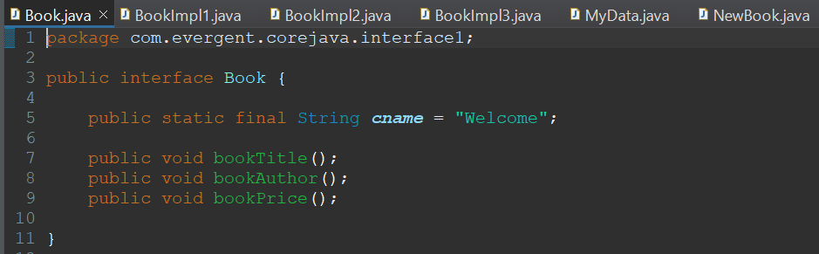
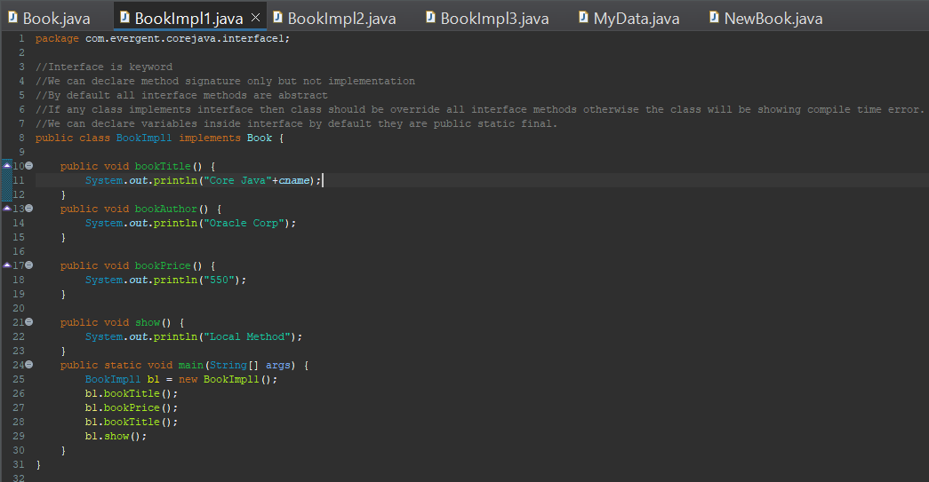
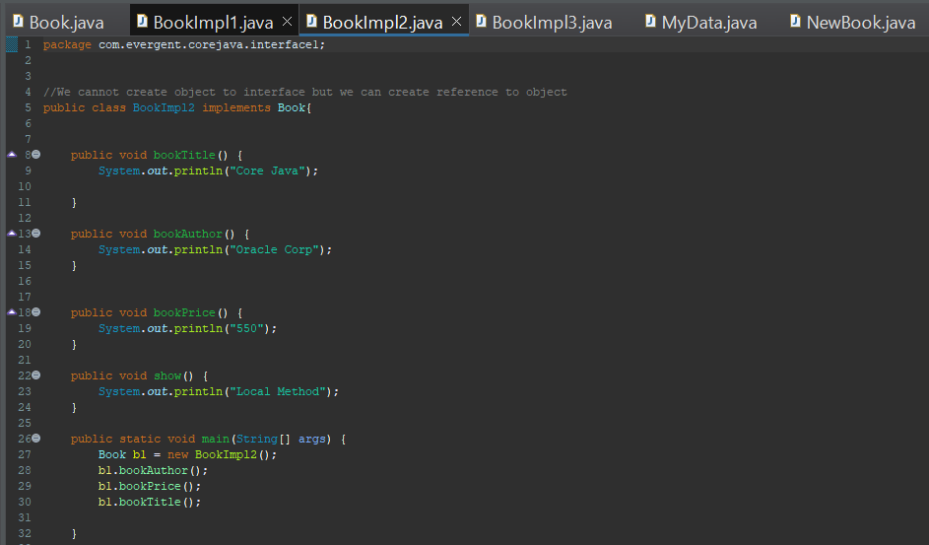
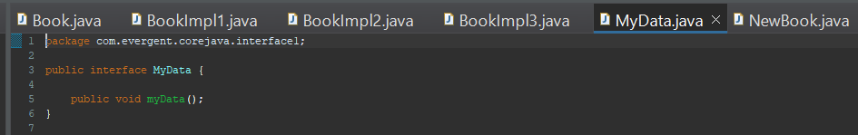
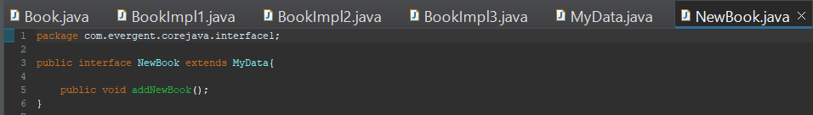
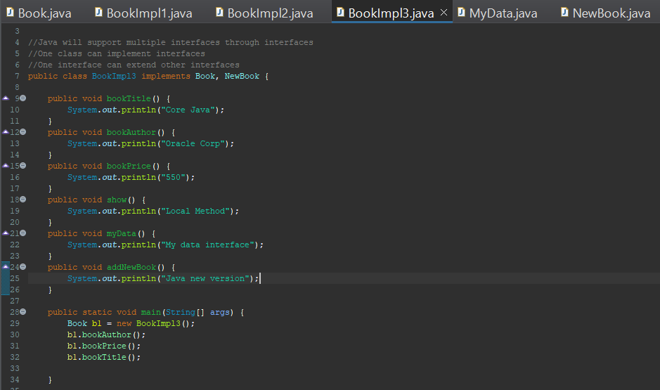

14/08/2024
- Abstract
- Abstract is a keyword
- Abstract class having abstract methods and concrete(implementation) methods
- If any class having one abstract method that class should be declared as a abstract otherwise that class will be showing compile time error
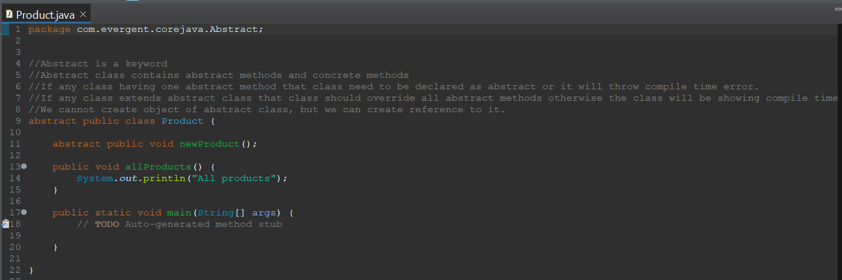
- If any class extends abstract class that class should be override all abstract methods otherwise the class will be showing compile time error
- We cannot create object to abstract class, but we can create reference to it.
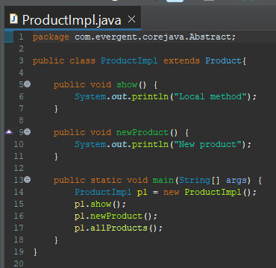
- Abstract class constructor will be called automatically during object class creation
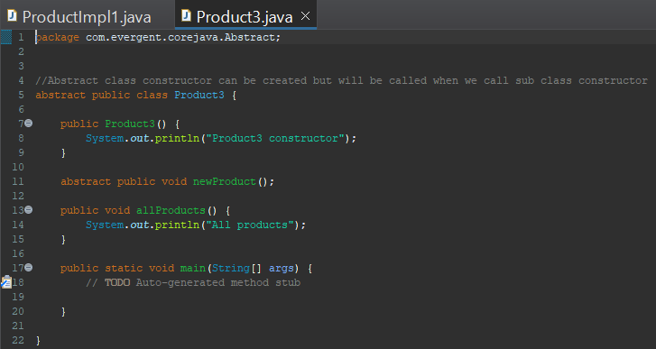

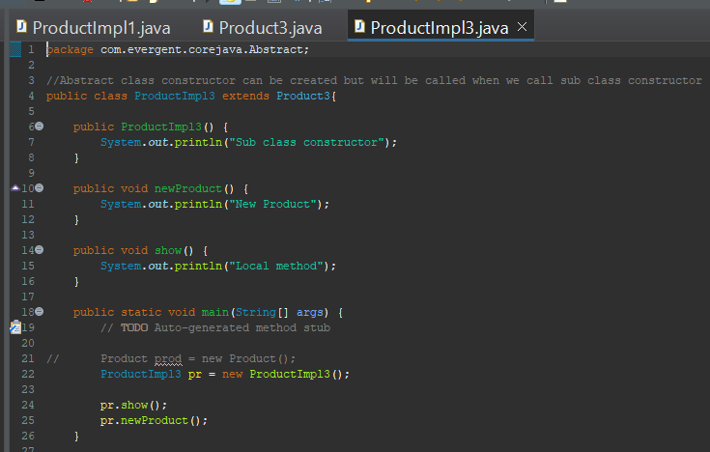

19/08/2024
- Exception
- Exception handling is a mechanism
ii. Exceptions are in built mechanisms of java
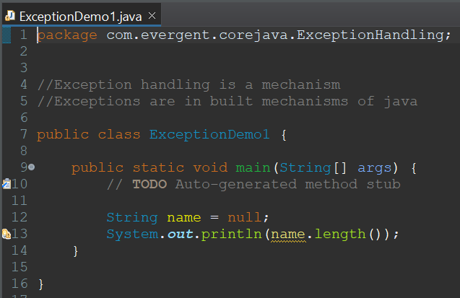
iii. All exception are executed while abnormal conditions only
iv. It wont execute any exceptions in normal flow
v. Once any exceptions are occurring in java code then remaining lines of code is unreachable
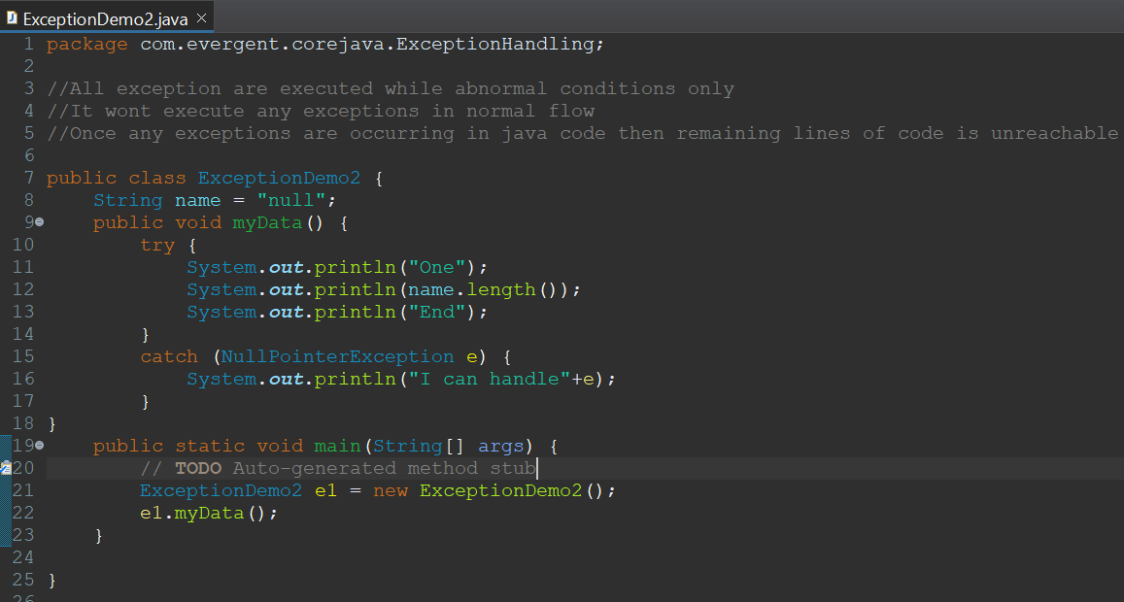
vi. Java.lang.Throwable is super class for exceptions and errors
vii. There are 2 types of exceptions
I. Checked Exceptions
II. Unchecked Exceptions
viii. All checked exceptions are compile time exceptions
ix. All Unchecked exceptions are compile time exceptions
x. There are 5 keywords in Exception handl
I. try
II. catch
III. finally
IV. throws
V. throw
xi. try is for business logic
xii. catch is for handling exceptions
xiii. finally is block if exception occurs or not finally block will be executed
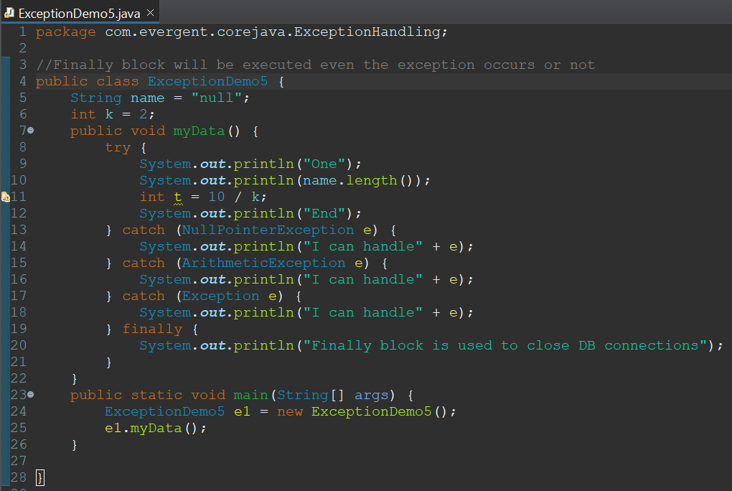
xiv. throws an exception is transferred from method to method
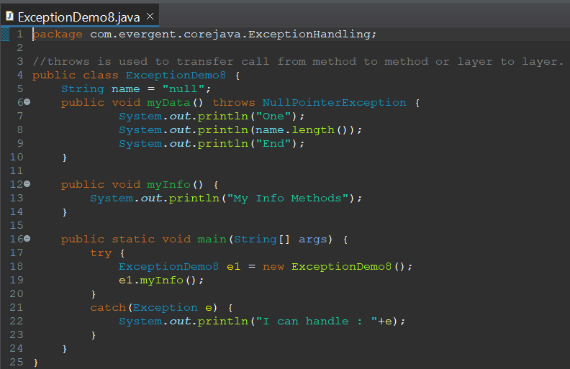
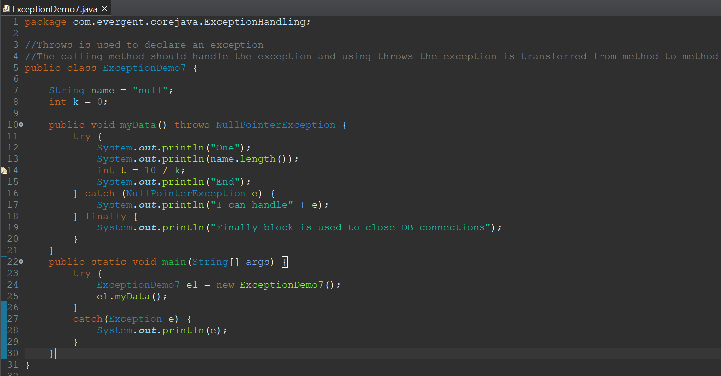
xv. throw is for runtime exceptions will call predefined exception classes and user defined exceptions.
xvi. Try follwed by either catch or final block
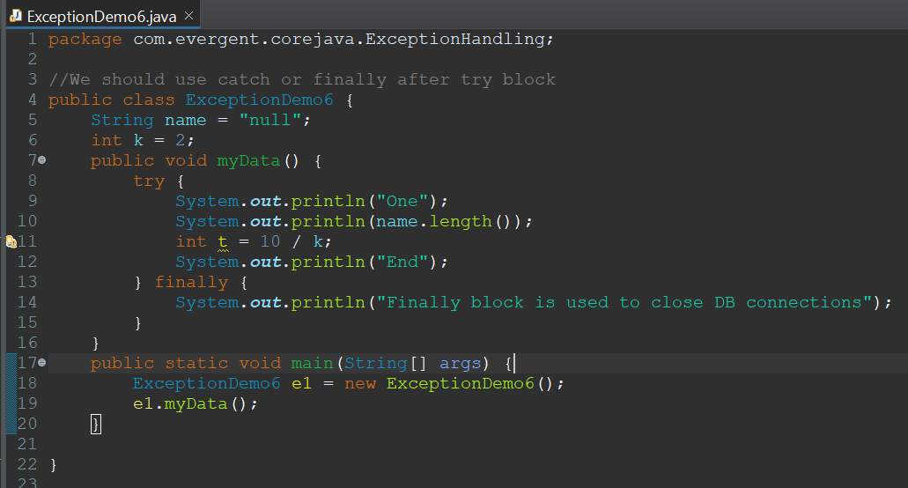
xvii. We should follow exception hierarchy
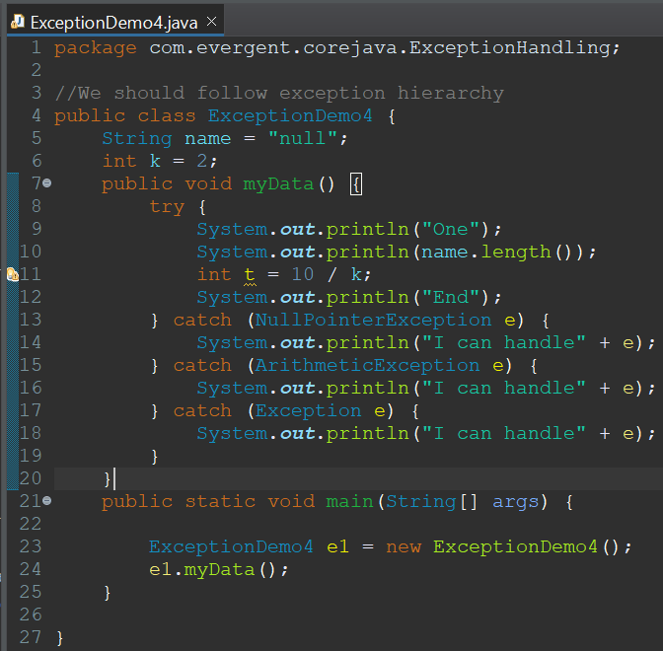
xviii. We can create our own user defined exceptions
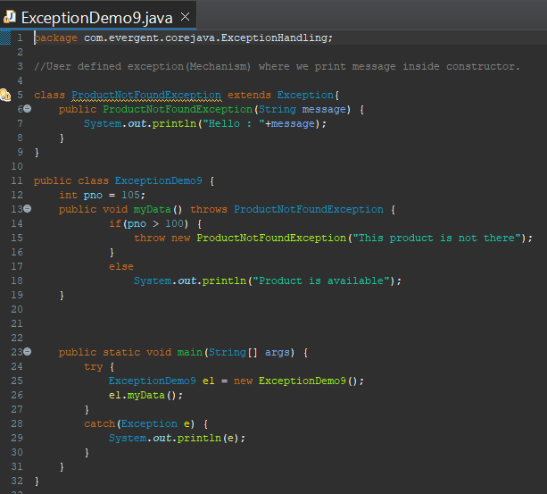
xix. Our own exceptions extend Exception or Runtime exceptions
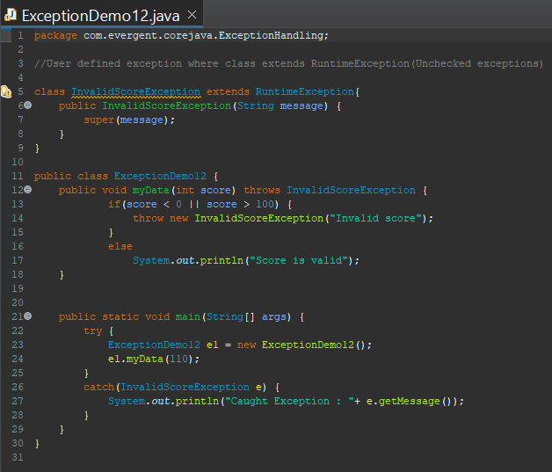
xx. All exception classes into java.lang package
xxii. If there are 2 exceptions in class developer should handle 1st exception then 2nd exception will be handled next.
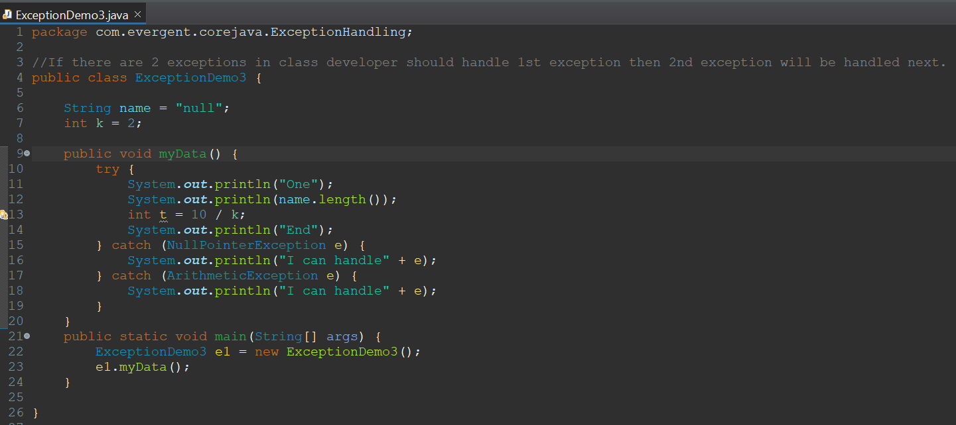
xxiii. Errors are not in developer control
